**PROGRAMMING IN C**

**ASSIGNMENT**

**ON**

**STRING FUNCTIONS**

**SUBMITTED BY:**

Deepak Joseph

Roll no:17

BCA: 1st year

**WHAT IS A STRING**

In c programming a string is a sequence of characters terminated with a null character. In other words, a string is a data type used in programming. it is used to represent text rather than just numbers.

It consists of a set of characters that can also contain spaces and numbers. Typically programmers must enclose strings in quotation for the data to be recognized as a string and not a number or variable.

**STRING HANDLING FUNCTIONS**

String handling functions are those which can be used to carry out many of the string manipulations. These functions are packed in the string.h library.

**1.strcat(): it is used to combine 2 strings**

**Example:**

**code:**

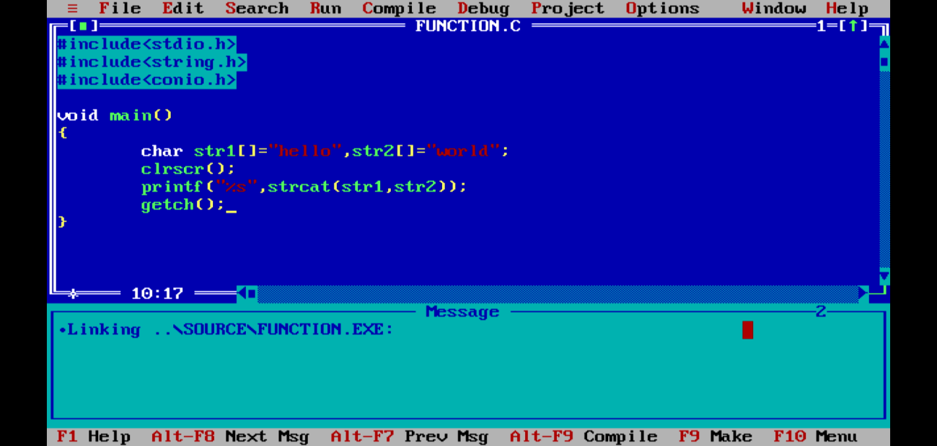

**output:**

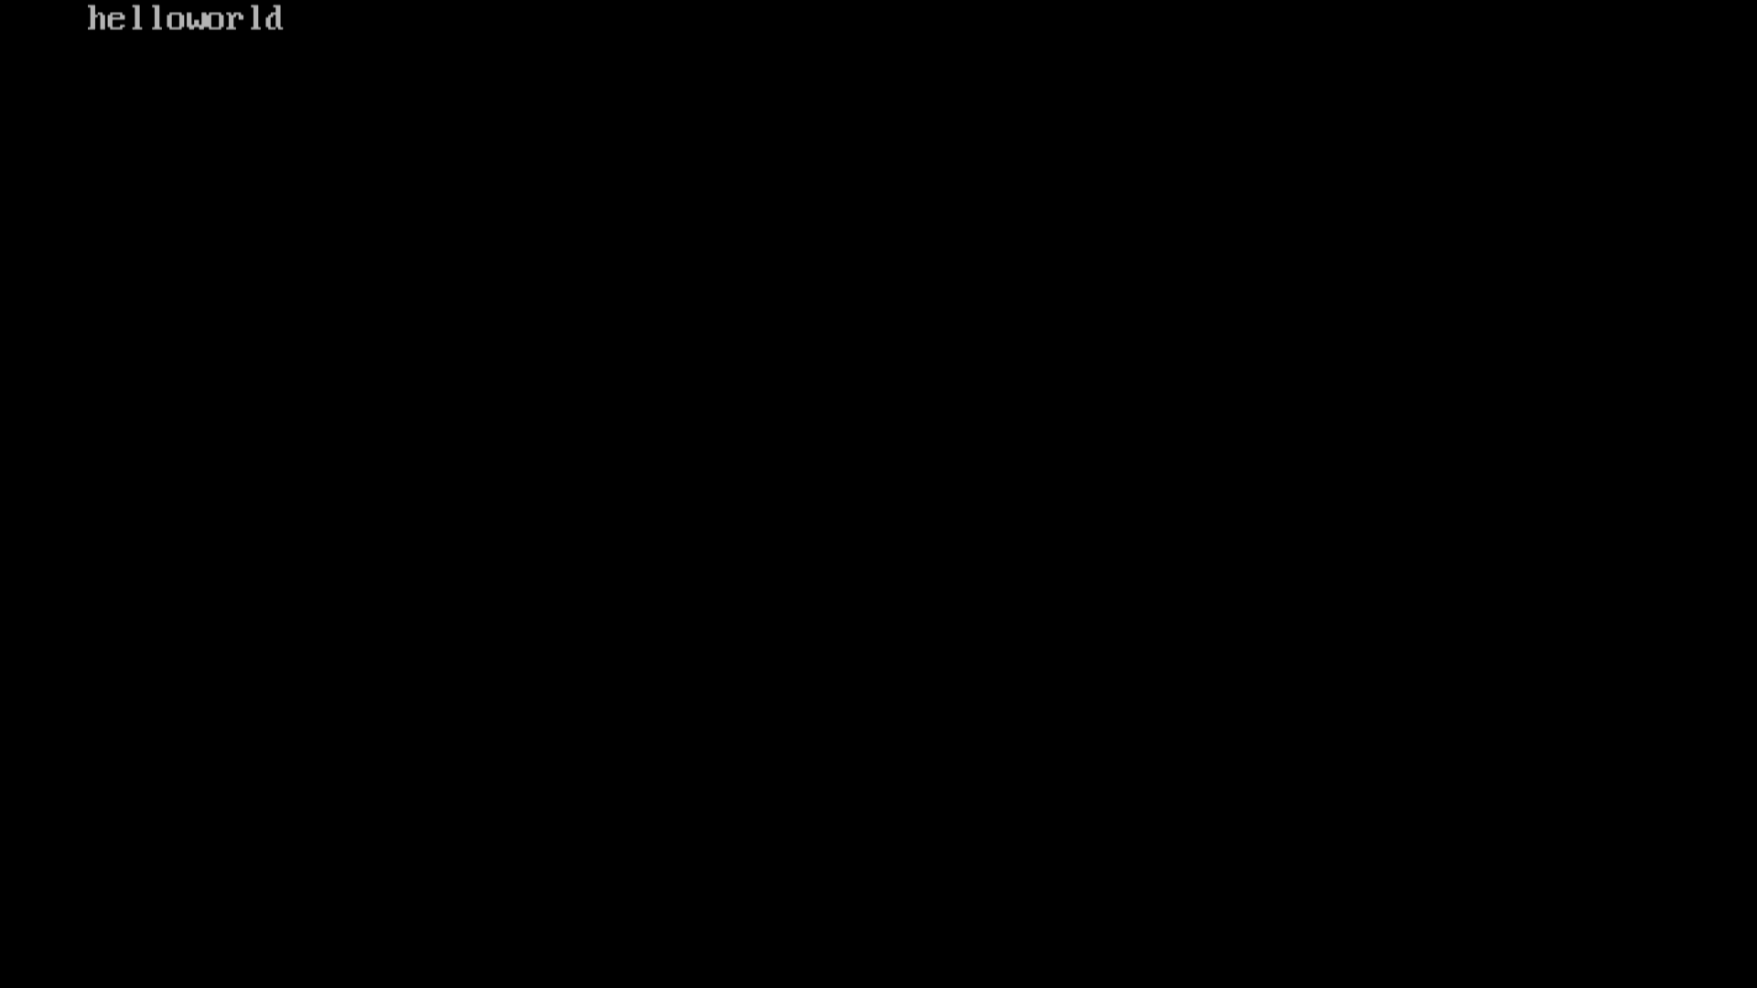

**2.strlen(): will return the length of the string passed to it**

**Example:**

**Code:**

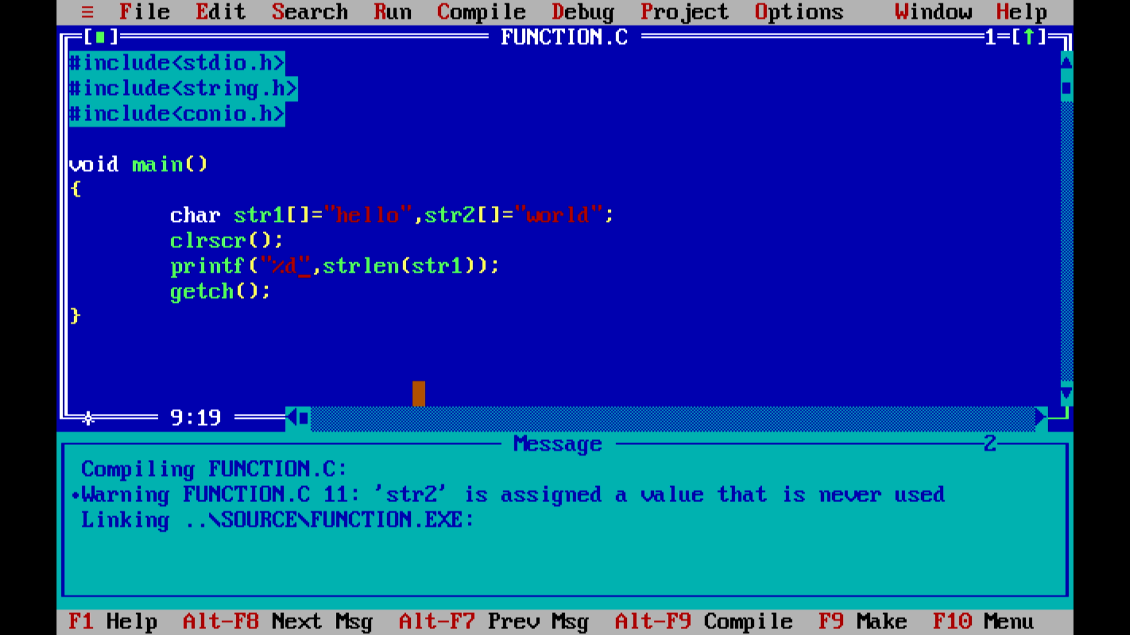

**Output:**

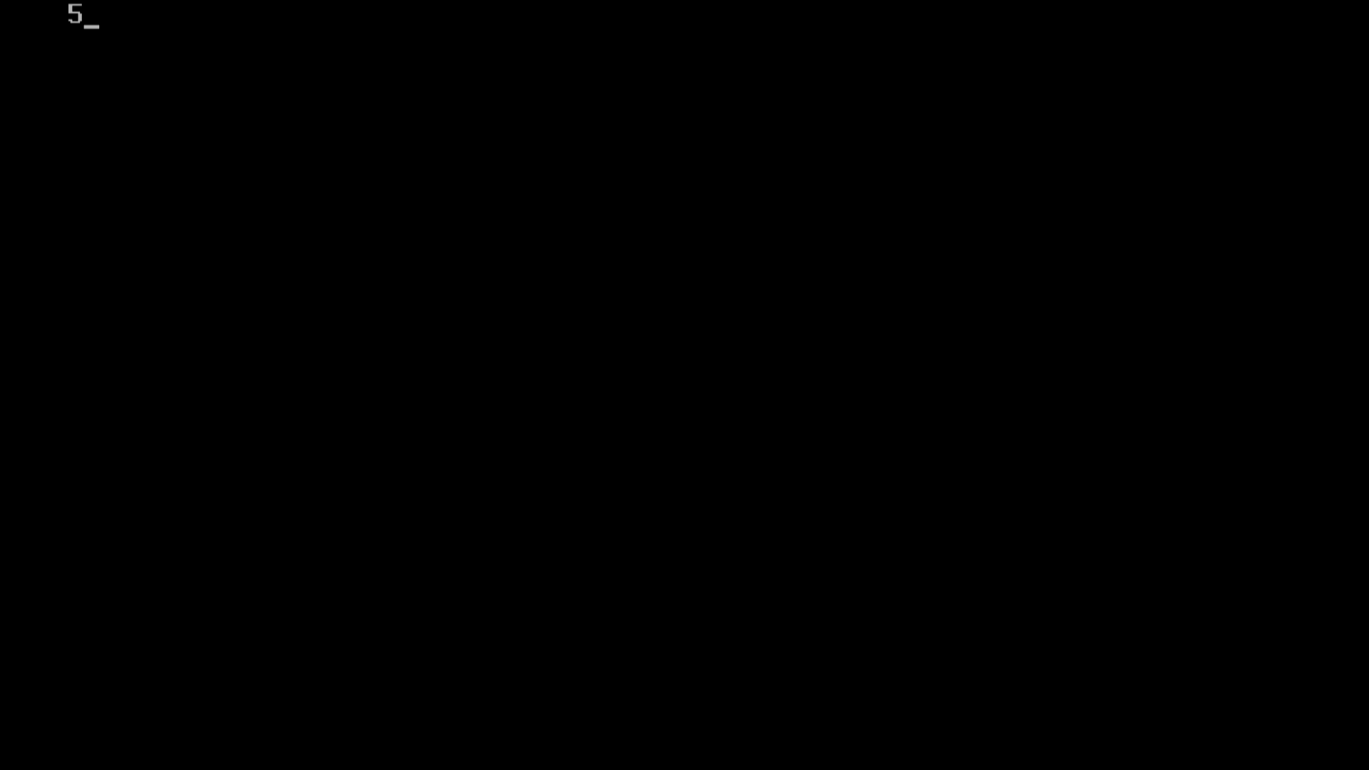

**3.strcmp(): will return ASCII difference between first unmatching character of two strings.**

**Example:**

**Code:**

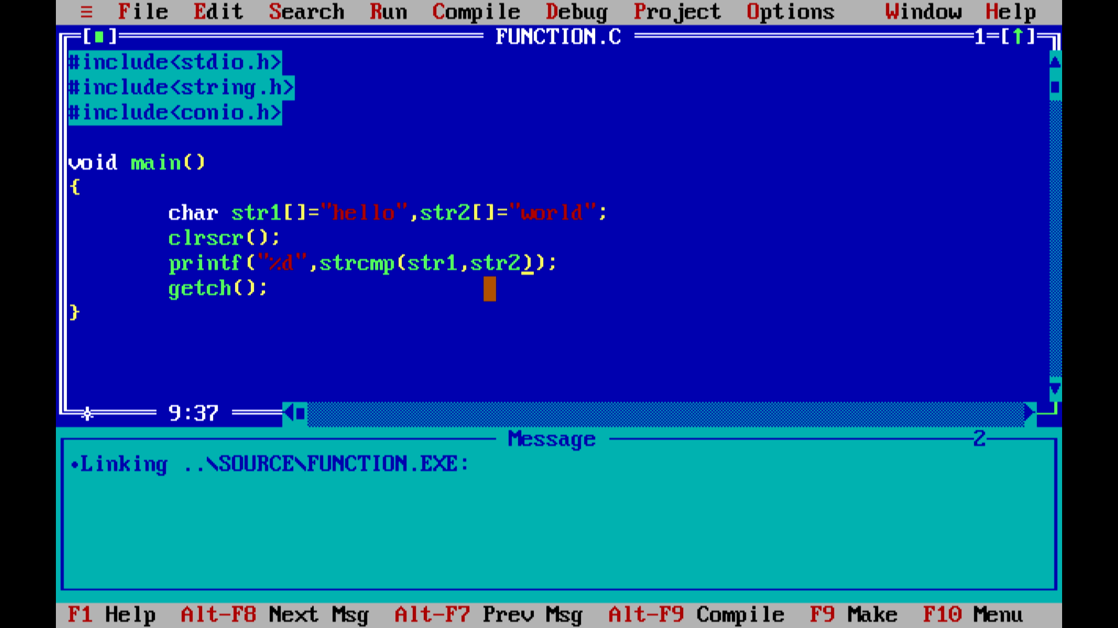

**Output:**

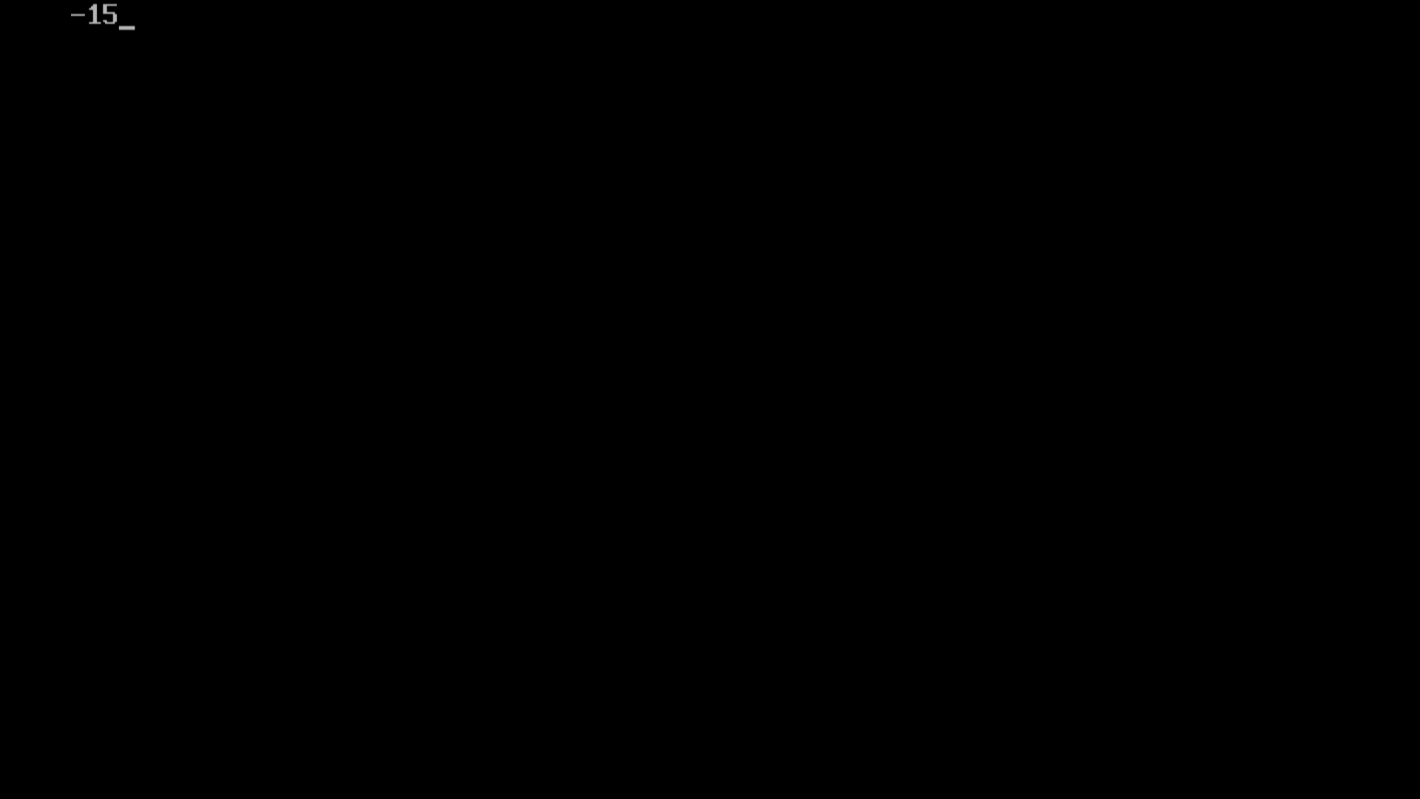

**4.strcpy(): will copy second string argument to the first string argument**

**Example:**

**Code:**

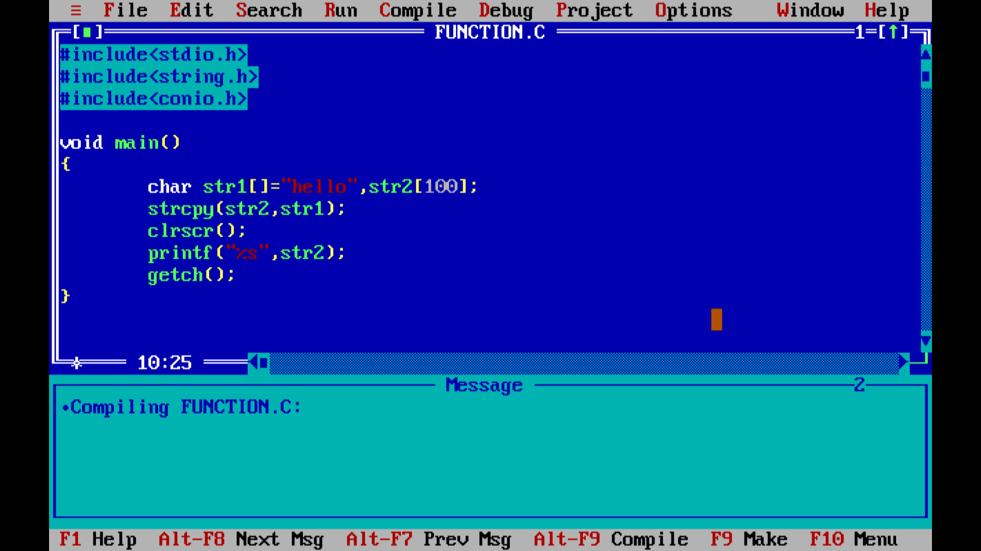

**Output:**

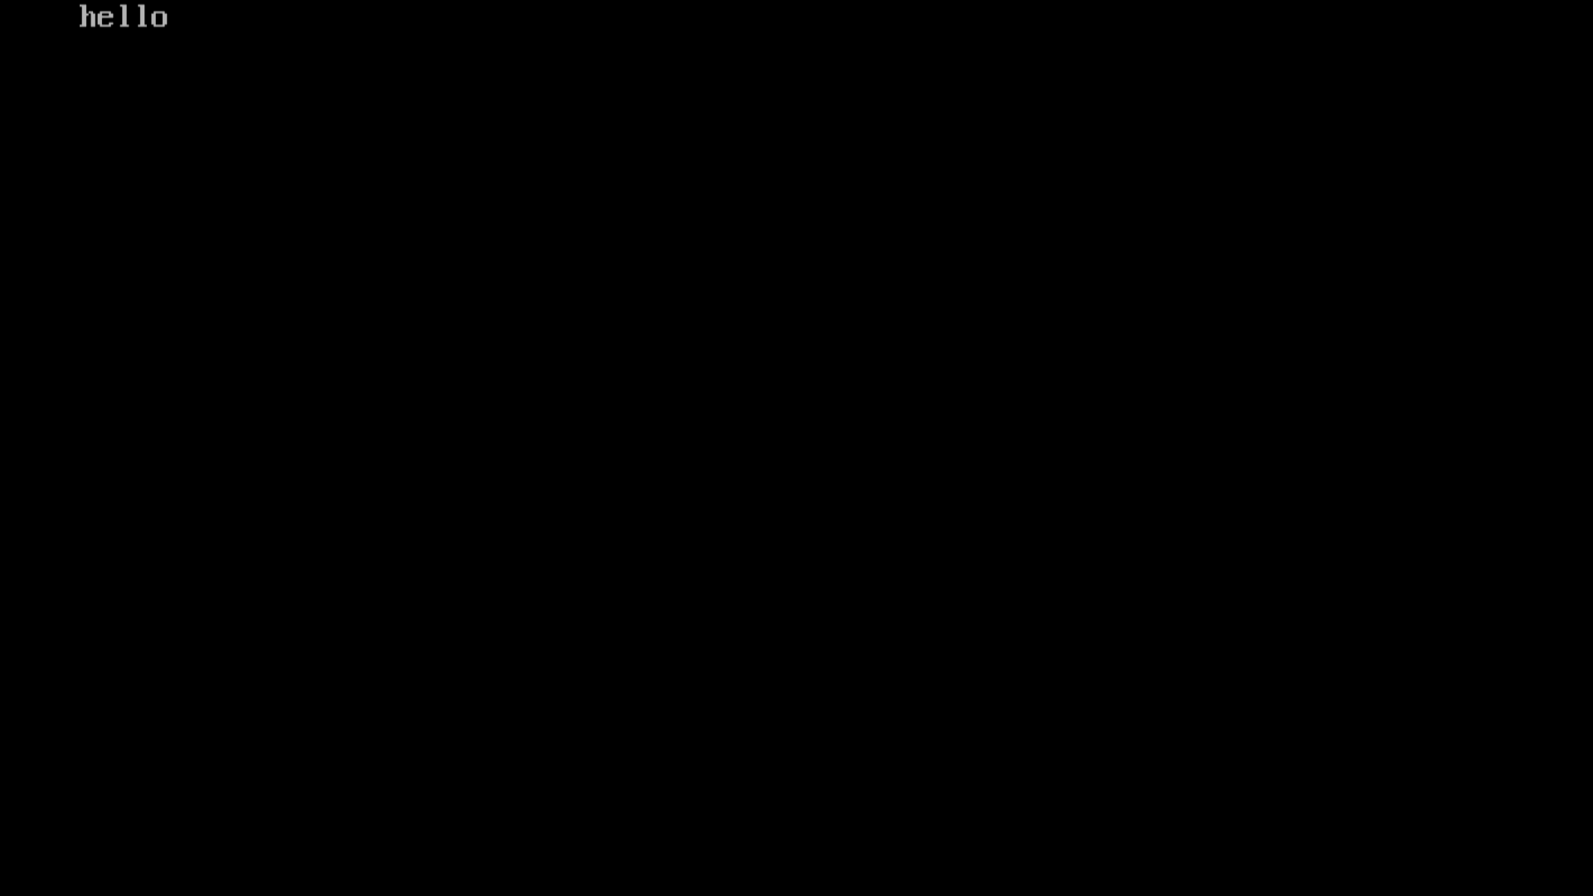

**5.strrev(): will reverse the given string**

**Example:**

**Code:**

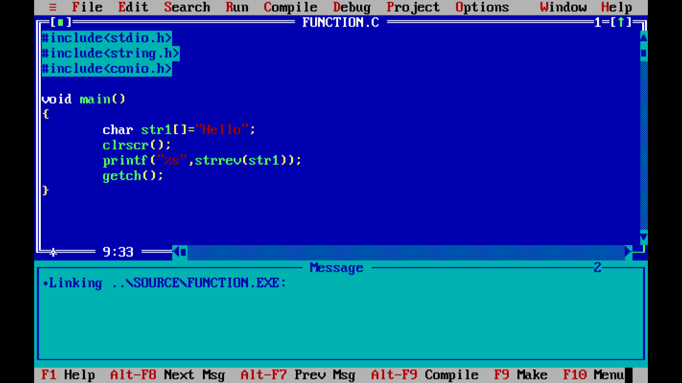

**Output:**

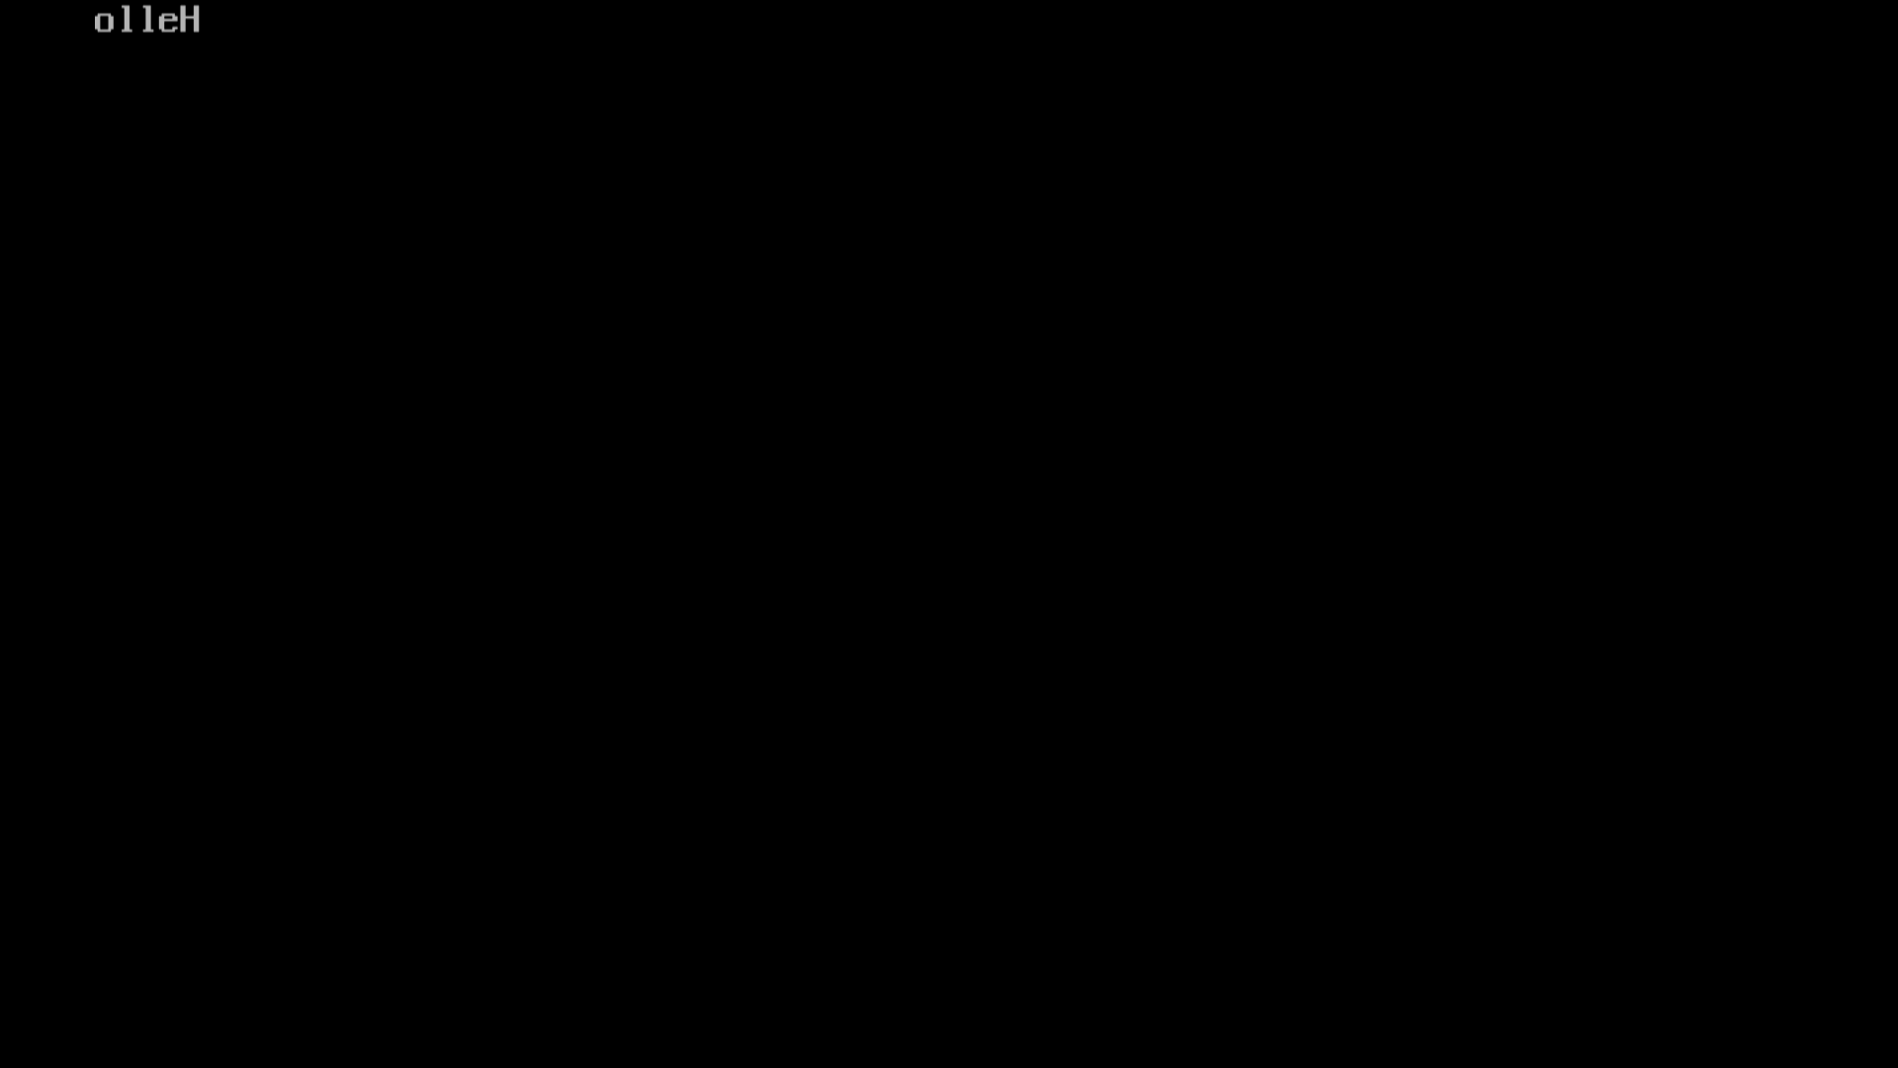

**6.strupr(): will change all lowercase letters of the given string to uppercase**

**Example:**

**Code:**

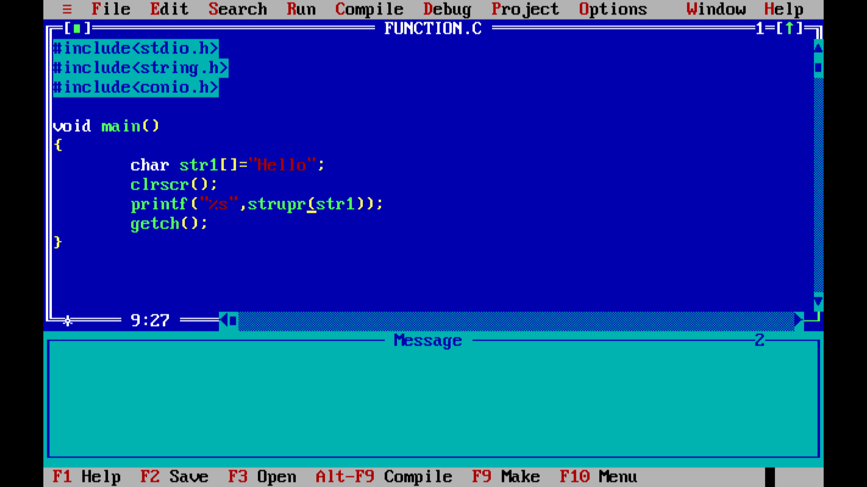

**Output:**

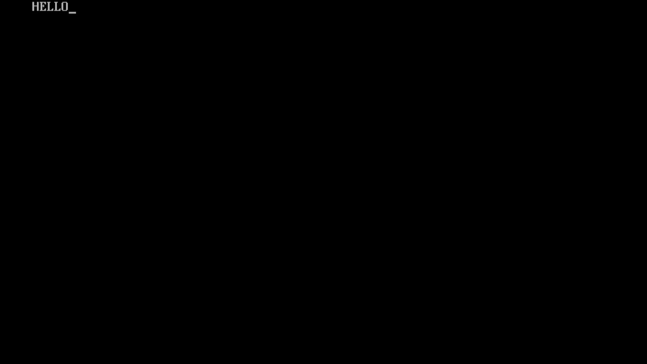

**7.strlwr(): will change all uppercase letters of the given string to lowercase**

**Example:**

**Code:**

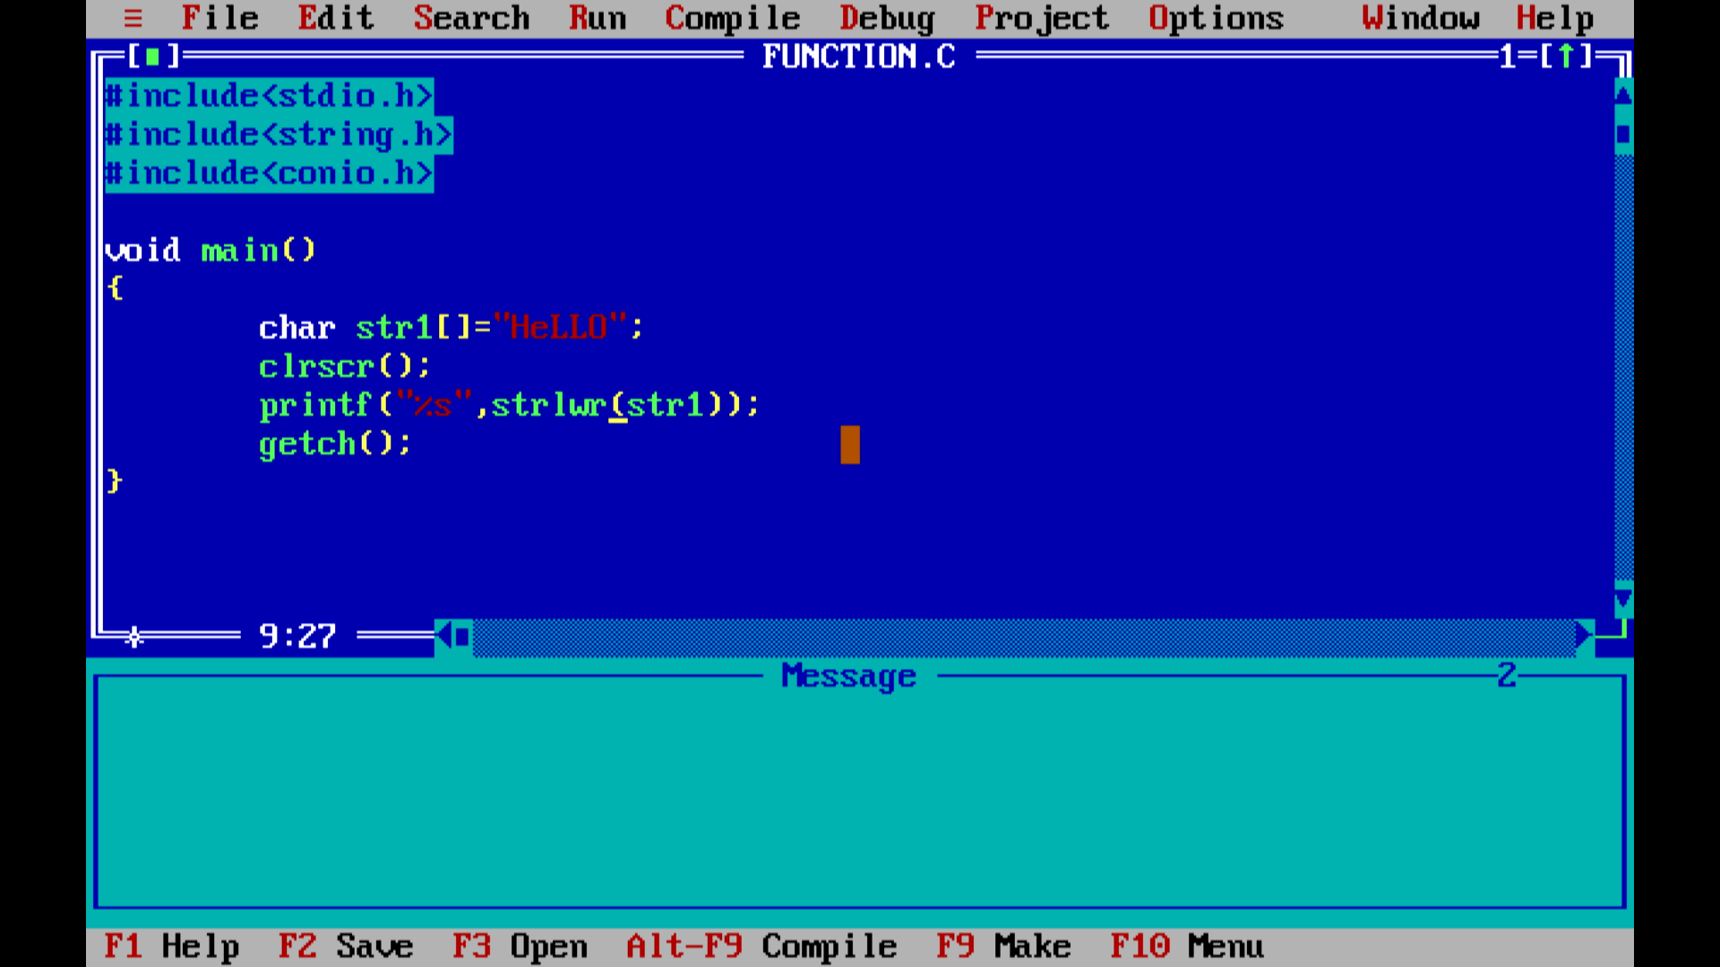

**Output:**

